**How to Download & Install MongoDB on Windows**



# Step 1 — Download the MongoDB MSI Installer Package

Head over  <https://www.mongodb.com/download-center/community> and download the current version of MongoDB. Make sure you **select MSI**as the package you want to download.

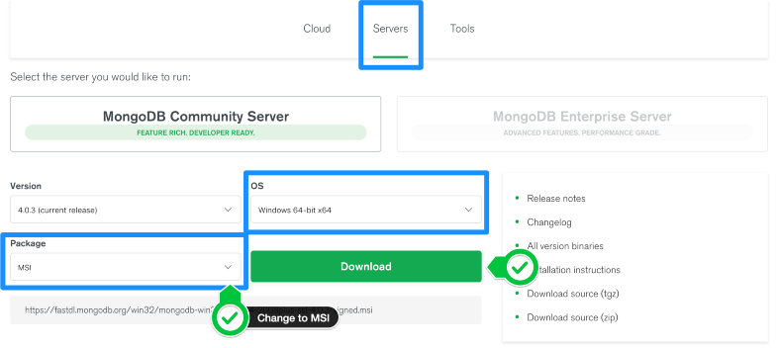

# Step 2 — Install MongoDB with the Installation Wizard

**A:-** Make sure you are logged in as a user with Admin privileges. Then navigate to your downloads folder and double click on the .msi package you just downloaded. This will launch the installation wizard.

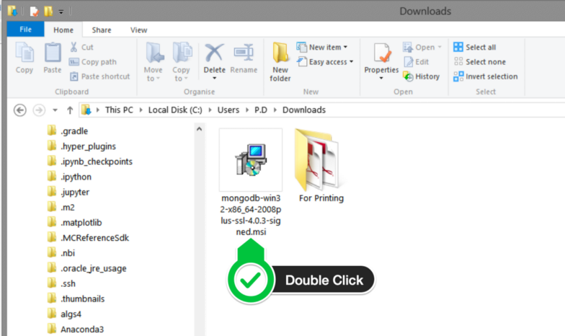

**B.** Click Next to start installation.

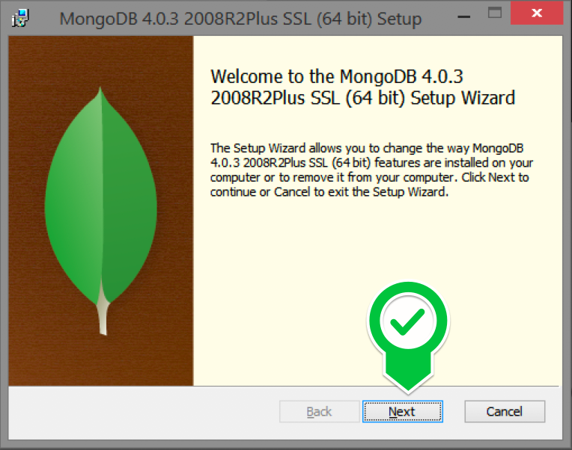

**C.** Accept the licence agreement then click Next.

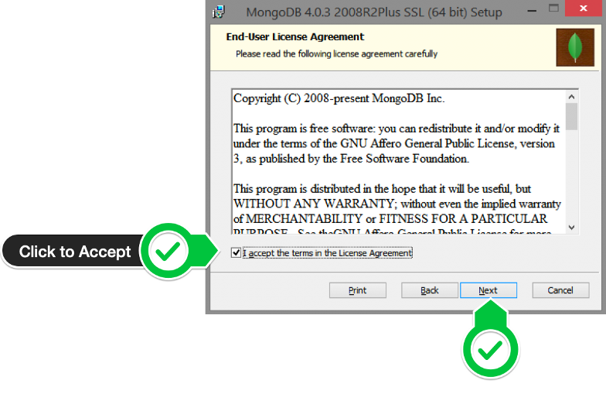

**D.** Select the Complete setup.

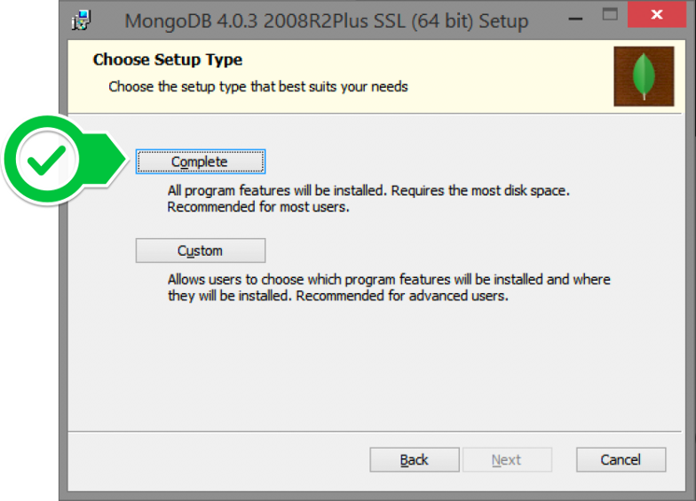

**E.** Select “Run service as Network Service user” and make a note of the data directory, we’ll need this later.

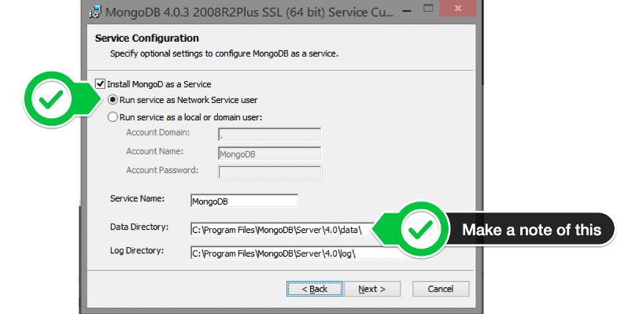

**F.** Click Install to begin installation.

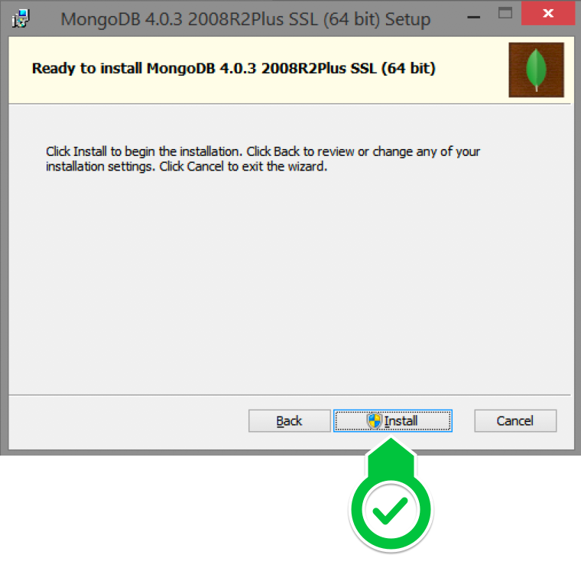

**G.** Hit Finish to complete installation.

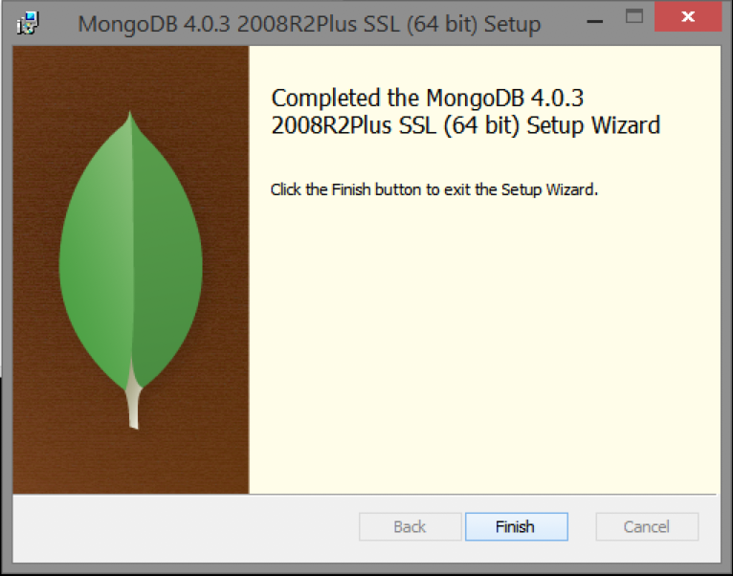

**Step 3:** Now we go to the location where MongoDB installed

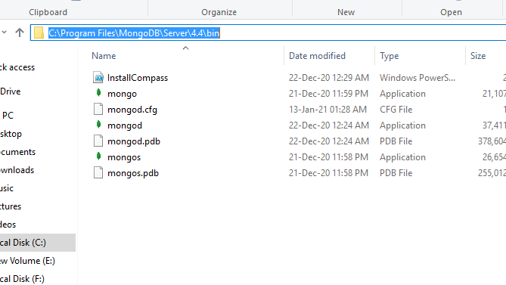

**Step 4:** Now, to create an environment variable open system properties << Environment Variable << System variable << path << Edit Environment variable and paste the copied link to your environment system and click Ok:

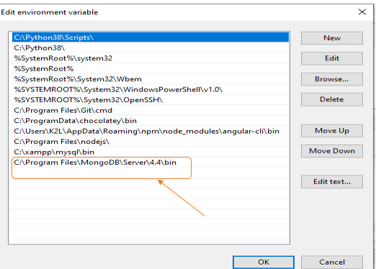

**Step 5:** After setting the environment variable, we will run the MongoDB server, i.e. mongod. So, open the command prompt and run the following command:

**mongod**

When you run this command you will get an error i.e. C:/data/db/ not found.

**Step 6:** Now, Open C drive and create a folder named “data” inside this folder create another folder named “db”. After creating these folders. Again open the command prompt and run the following command:

**mongod**

Now, this time the MongoDB server(i.e., mongod) will run successfully

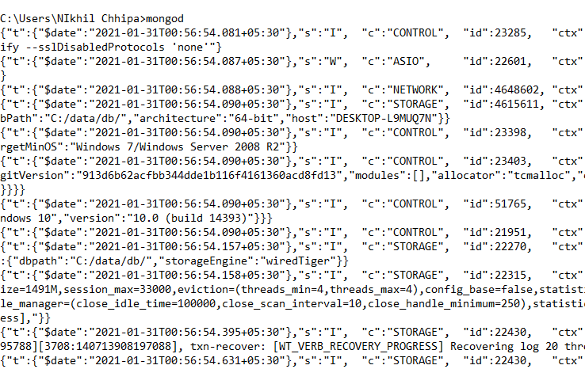

**Run mongo Shell**

Step 7: Now we are going to connect our server (mongod) with the mongo shell. So, keep that mongod window and open a new command prompt window and write mongo. Now, our mongo shell will successfully connect to the mongod.

Important Point: Please do not close the mongod window if you close this window your server will stop working and it will not able to connect with the mongo shell.

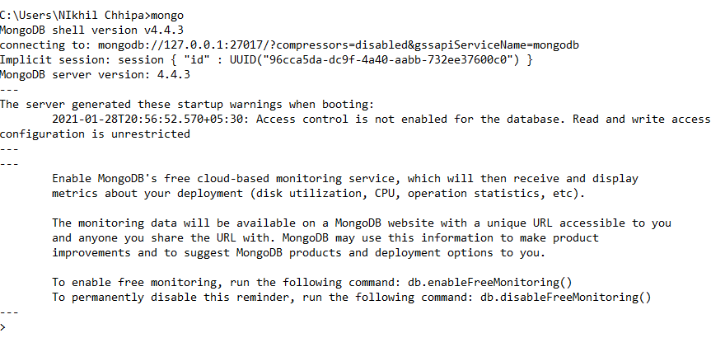

Now, you are ready to write queries in the mongo Shell.

**Example:**

Now you can make a new database, collections, and documents in your shell. Below is an example of how to make a new database:

The use Database_name command makes a new database in the system if it does not exist, if the database exists it uses that database:

**use gfg**

Now your database is ready of name gfg.

The db.Collection_name command makes a new collection in the gfg database and the insertOne() method inserts the document in the student collection:

**db.student.insertOne({Akshay:500})**

